# New support 20170316

## 日志类型管理

### 基本操作

创建

curl -X POST 127.0.0.1:8080/logtype -d '{"Type":1,"Level":1, "Content":"device stat info"}'

{

"Object": {

"Id": 1,

"Type": 1,

"Level": 1,

"Updated": "2017-03-15 17:08:37",

"Content": "device stat info"

}

}

删除

curl -X DELETE 127.0.0.1:8080/logtype?id=1

"delete success"[root@bogon:qcserver git(master)]$ curl -X POST 127.0.0.1:8080/logtype -d '{"Type":1,"Level":1, "Content":"device stat info"}'

{

"Object": {

"Id": 3,

"Type": 1,

"Level": 1,

"Updated": "2017-03-15 17:13:46",

"Content": "device stat info"

}

}

查找

curl -X GET http://127.0.0.1:8080/logtype/list?pageidx=0\&pagesize=0

{

"objects": [

{

"Id": 2,

"Type": 2,

"Level": 5,

"Updated": "2017-03-15 17:09:44",

"Content": "print with no paper"

},

{

"Id": 3,

"Type": 1,

"Level": 1,

"Updated": "2017-03-15 17:13:46",

"Content": "device stat info"

}

],

"totalnum": 2

}

更新

curl -X PUT 127.0.0.1:8080/logtype -d '{"Id":3, "Type":5,"Level":3, "Content":"device stat info"}'

{

"Id": 3,

"Type": 5,

"Level": 3,

"Updated": "2017-03-16 14:35:11",

"Content": "device stat info"

}

### 界面

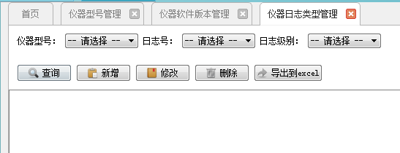

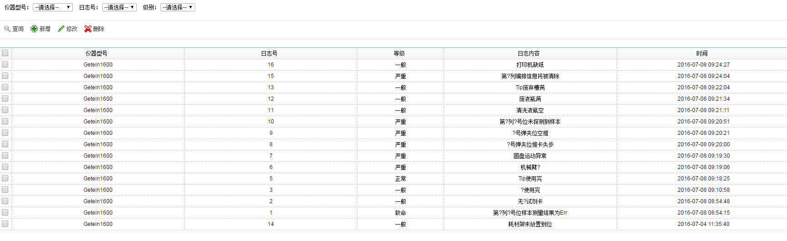

上图没有仪器型号栏，日志好即对应的id，时间即为updated

## 仪器出厂管理

### 添加省市查询

表头查询也需加上省市的查询，如下图

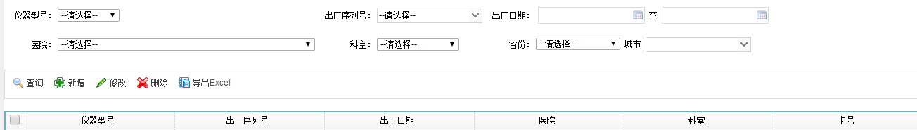

**支持**

curl -X GET 127.0.0.1:8080/devrel/list?pageidx=1\&pagesize=0\&***prov="Beijingshi"***

curl -X GET 127.0.0.1:8080/devrel/list?pageidx=1\&pagesize=0\&***city="Haidianqu"***

## 试剂研发管理

### 添加项目号及单位

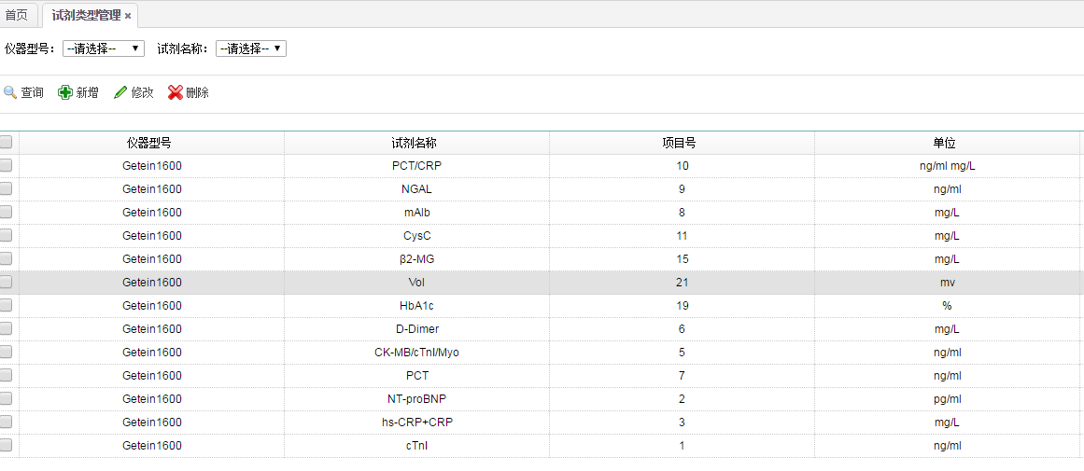

**支持**

curl -X POST -d '{"Name":"regmodel1", "Annotation":"anno1", "PrjId":10, "Unit":"ng/ml"}' 127.0.0.1:8080/reagentmodel?devmodel=devmodel1